do-while Script

Script to run for a number of times

#!/bin/bash

c=1
while [ $c -le 5 ]
do
echo "Welcone $c times"
(( c++ ))
done

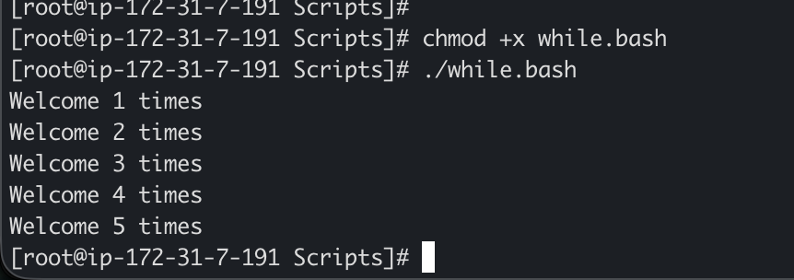

Script to run for a number of seconds

#!/bin/bash

count=0
num=10
while [ $count -lt 10 ]
do
echo
echo $num seconds left to stop this process $1
echo
sleep 1

num=`expr $num - 1`
count=`expr $count + 1`
done
echo
echo $1 process is stopped!!!
echo

